*­­*

**Instructor**: Mr. Hany Al-ghaithi.

Pleasant Tours

***2020, HTML5 eProject***

**eProject Title**

**Group Members**

**Student**1256882

Hesham Mohammed Noaman

**Student**1256877

Mohammed Hussein Qa’atabi

**Student**1256800

Ali Mohammed Aljawfi

**Student**125894

Osama Nasser Al-koli

**Student**1256886

Maryam Fahd Hajeb

­

Project Certification

This is to certify that,

**Mr. Mohammed Hussen Qa’atabi**

**Mr. Hesham Mohammed Noaman**

**Miss Maryam Fahd Hajeb**

**Mr. Osama Nasser Al-koli**

**Mr. Ali Mohammed Aljawfi**

Has successfully Designed & Developed

**-------------------------------------------------------------------------------------------------------**

**Pleasant Tours**

**-------------------------------------------------------------------------------------------------------**

**Submited by:**

[Mohammed Qa’atabi, Hesham Noaman, Maryam Hajeb, Osama Al-koli, Ali Aljawfi]

**Date of Submission**: 04/05/2020

**Authorized Signature** : ------------------------------------

# **Table Of Contents**

**Acknowledgment**

**Problem Statement**

**Requitemtns specification**

* **Hardware Requitements**
* **Software Requitements**

**Project Design**

* **Architecture and Design of the System**
* **Project Layout**
* **Site Map**
* **GUI Map**
* **Snap shots**

**Requirements Fullfillment checks and Addidtional Features**

**Requirements Checklist**

**Task Sheet**

**Checklist of Validations**

**Submission Checklist**

**Source Code**

**User Guide**

# **Acknowledgment**

We would like to acknowledge all those who have given us moral support and helped in making the project a success.

We wish to express our gratitude to eProject Team at Head Office who guided and helped us.

Thanks to our teacher **Mr. Hany Al-ghaithi** who guided us during the Project.

Also, we would like to express our gratitude to all the staff members of our center for not only providing us an opportunity to work with them on this project, but also for their support and encouragement throughout the process.

# **Problem** **Statement**

Pleasant Tours is into selling various tour products. They have predefined tours with itineraries. The company advertises by distributing the pamphlets, advertising on television and so on. Due to rapid development in internet field, the company decides to launch a website where people will get all the information about the various tour products available with them easily.

The website is to be developed for the Windows Platform using HTML5, JavaScript and Geolocation. The site should work well in all leading browsers including Chrome, IE, Firefox etc.

# **Requrements Specification**

### The Web Site is to Be Created Based on the following requiremtns:

1. The Home Page should be created making use of Frames with a suitable logo
2. The site should display a menu which will contain the options for brief introduction about the various products available, location of the shop and any other information if required.
3. The information should be categorized according to different type of products like if a User wants to see only ‘Beach Tours’ then he clicks on a Link/button/menu etc. and he will see different type of Beach Tours. Similarly, for ‘Hill Stations’, ‘Forts/Palaces’ and other products
4. When a user selects any product type, a list of products for that product type will be displayed.
5. Itinerary of individual tour products should be displayed on the Web Page along with the title but detailed itinerary should be stored in Individual Word documents which can be downloaded or viewed by the User who wishes to see the same.
6. Price List for all tours should be available for download.
7. There should be a “Contact Us” page which will have the Address of the Company which is as follows and the mail address which when clicked will invoke the local mail client from where they can send an email. Address of the Company should be displayed using Geolocation API (e.g. Google Maps).

# **Requiremnts specigication**

## Hardware:

### Software:

* Notepad/HTML editor
* Dreamweaver
* IE 5.0/ Netscape 6.0
* A minimum computer system that will help you access all the tools in the courses is a Pentium 166 or better.
* 64 Megabytes of RAM or better.

# **Project Design**

## Architecture and Design of the System

#### The application will have a client-server architecture.



## Project Layout

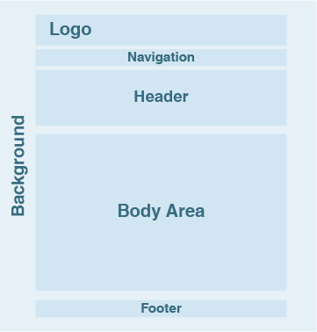

## Site Map

### The sample site map illustrates the navigation flow of the objects on the Web portal.

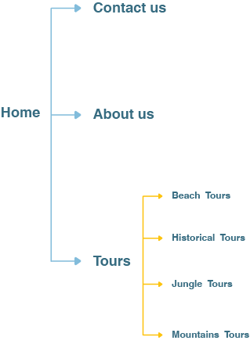

## GUI MAP

### Home:

Contains the main slider of the site displaying images of various tours of different types with the clients review about the products.

### About us:

This page contains the introduction to the company and clients review about the products.

### Contact us:

This page contains the comment box where the user can provide her/his feedback and the company location.

### Type pages:

These pages contain the tours of each type.

### Details pages:

These pages contain each tour specification and detailed itinerary.

## Snap shots

### Home Page

### About us page

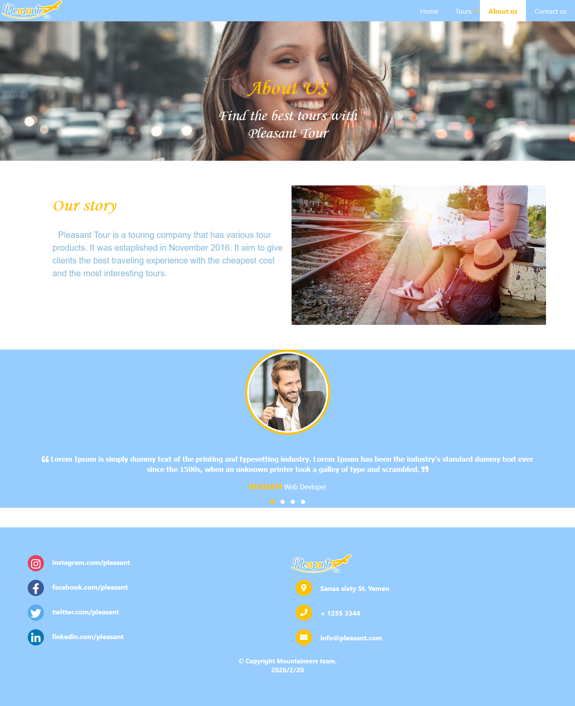

### Contact us page

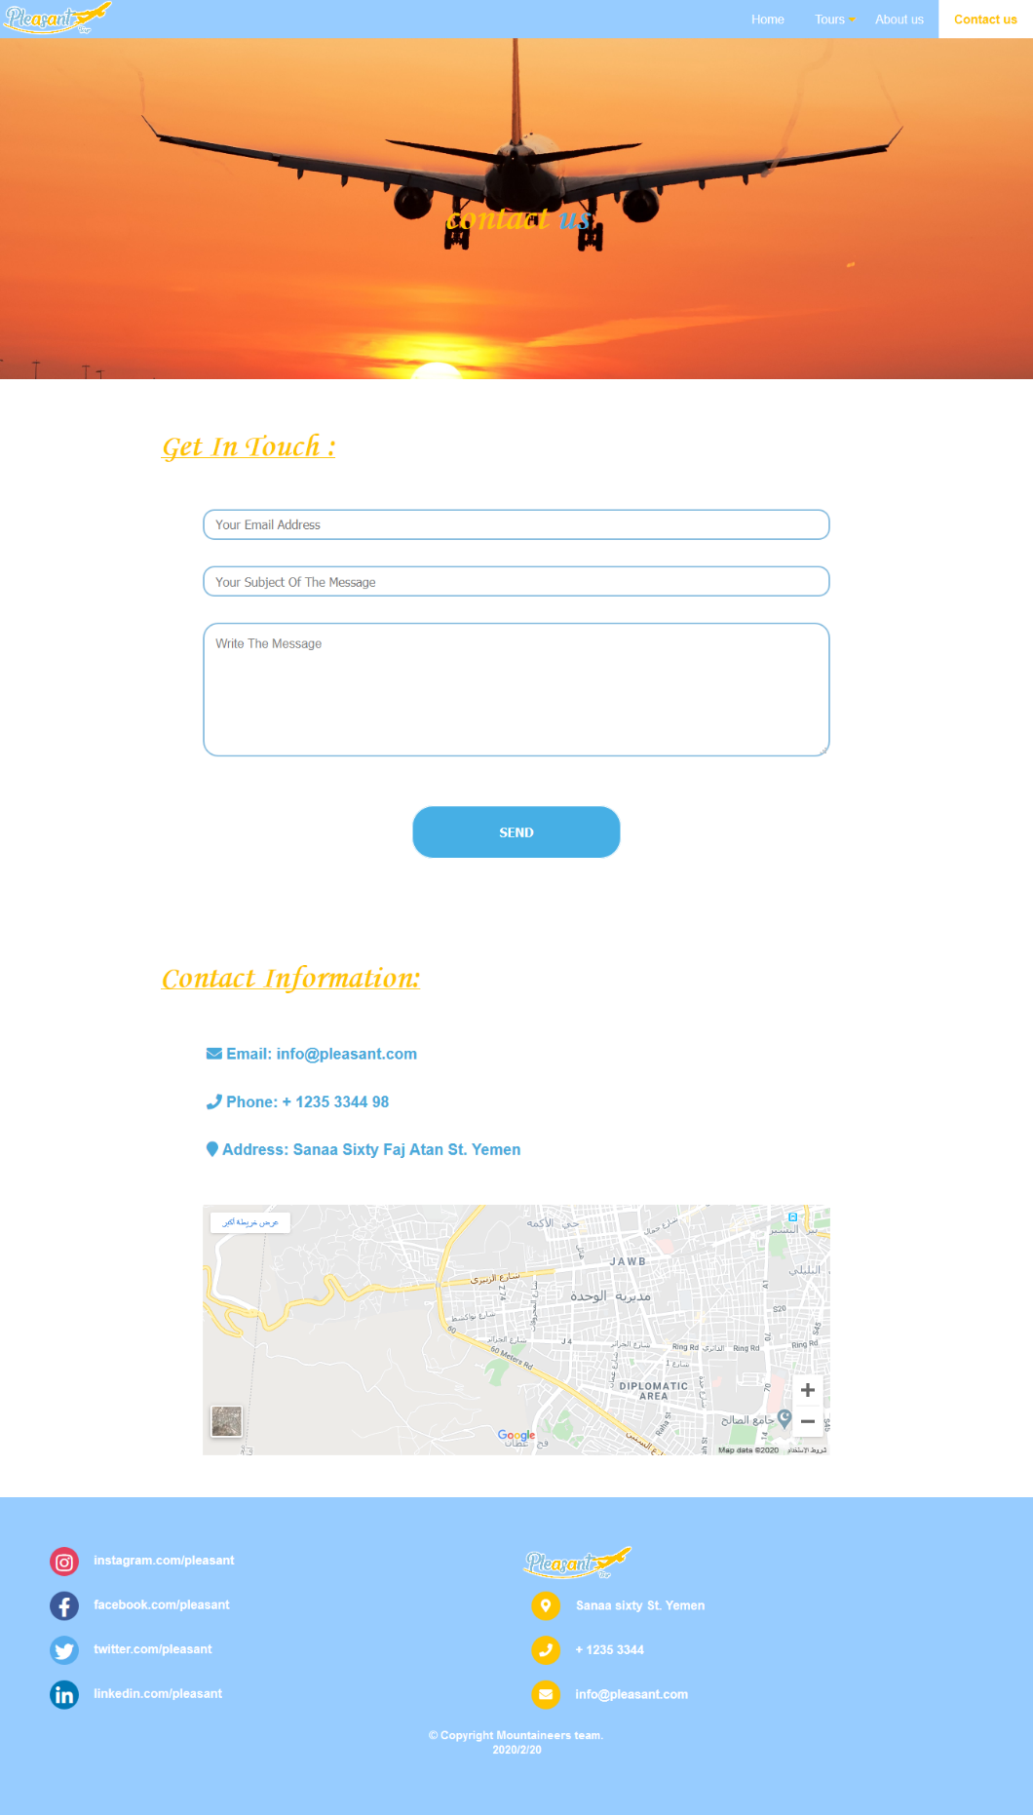

### Tours Types page

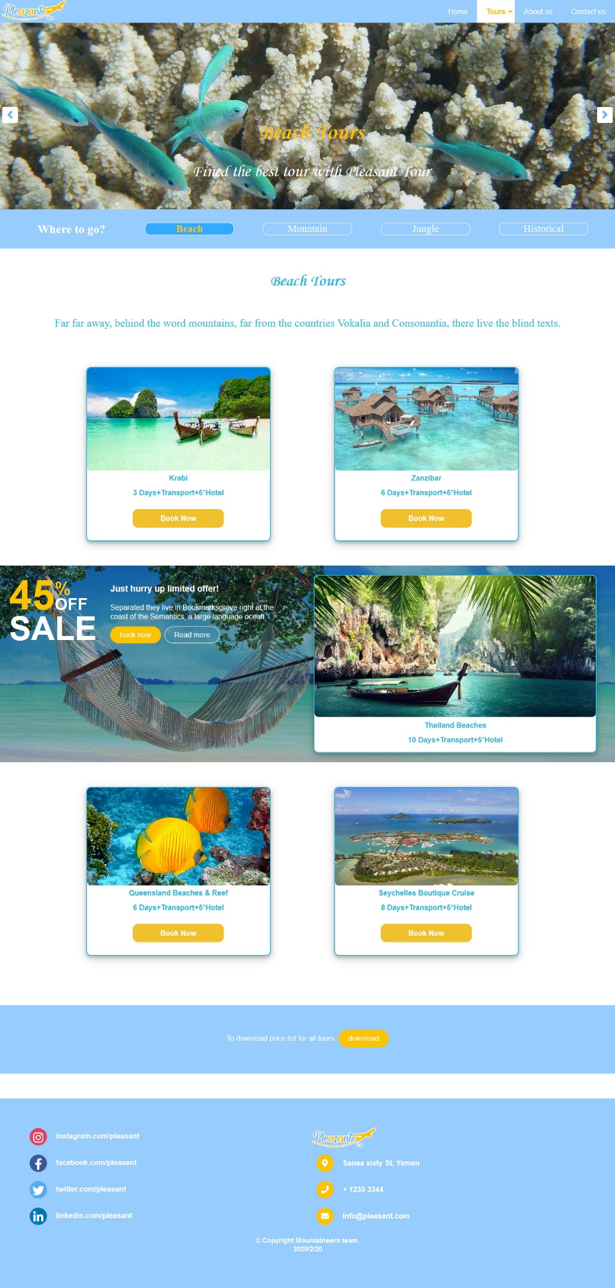

### Tour Details page

# 

# Requiremnt Fulfillment checks

### All the required features have been highlighted with their specification in text format

1. Home page containing a suitable logo

­­

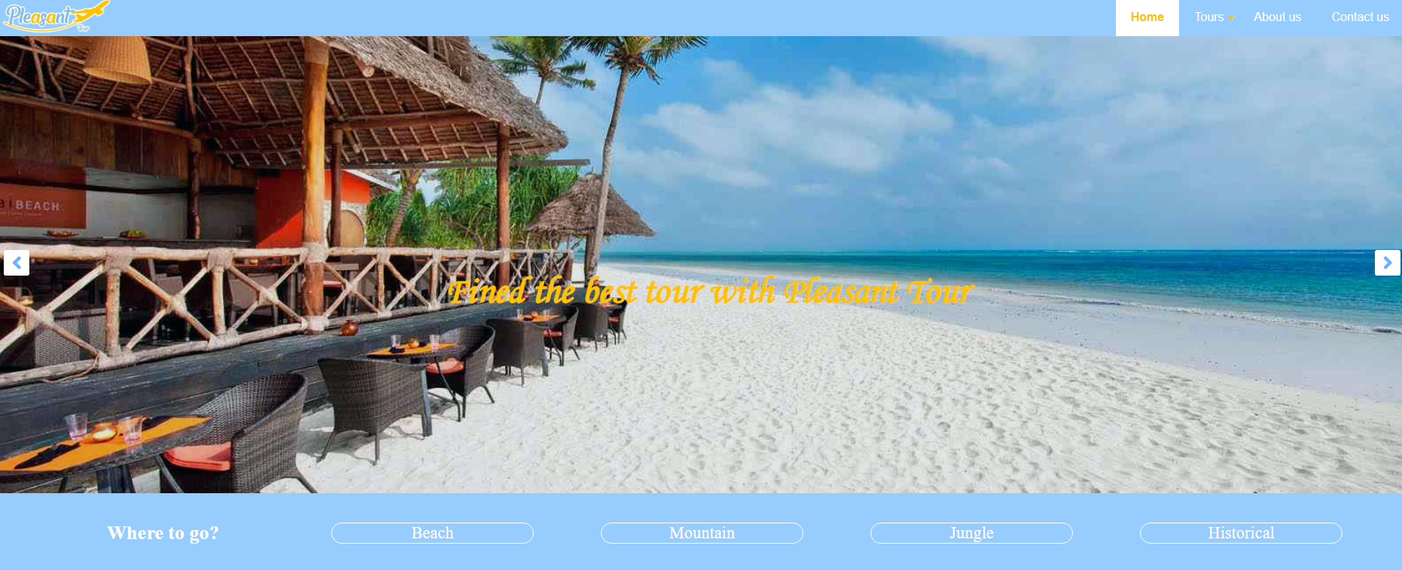

1. The site should display a menu which will contain the options for brief introduction about the various products available, location of the shop and any other information if required.

**­**

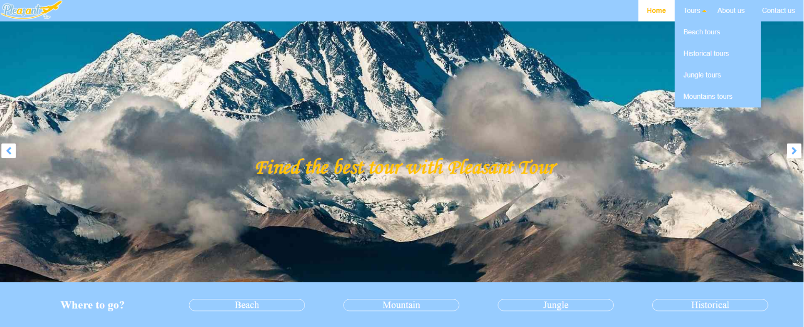

1. 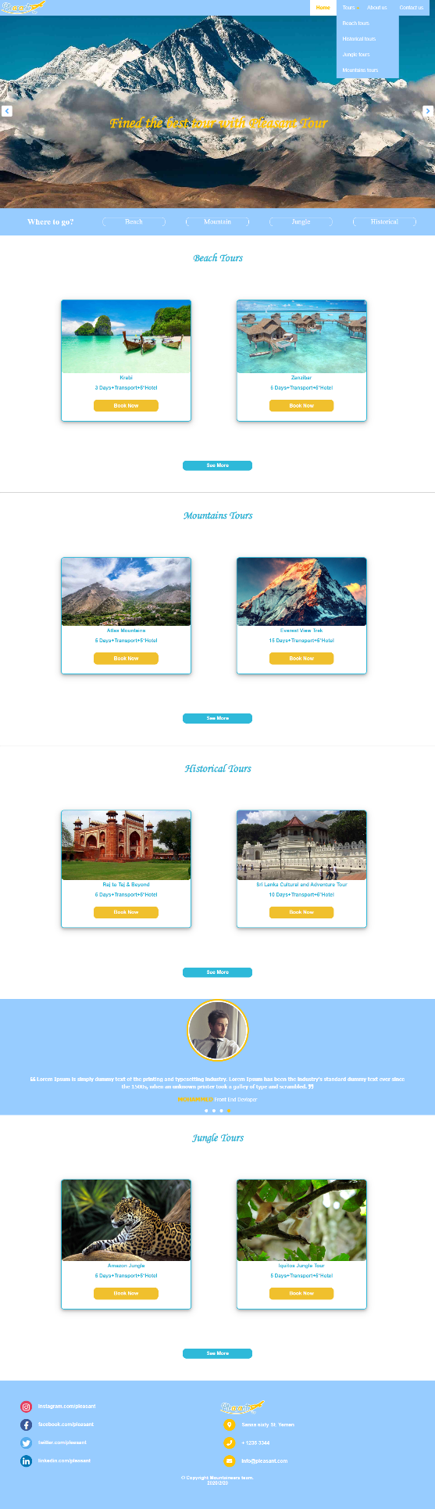The information should be categorized according to different type of products.
2. 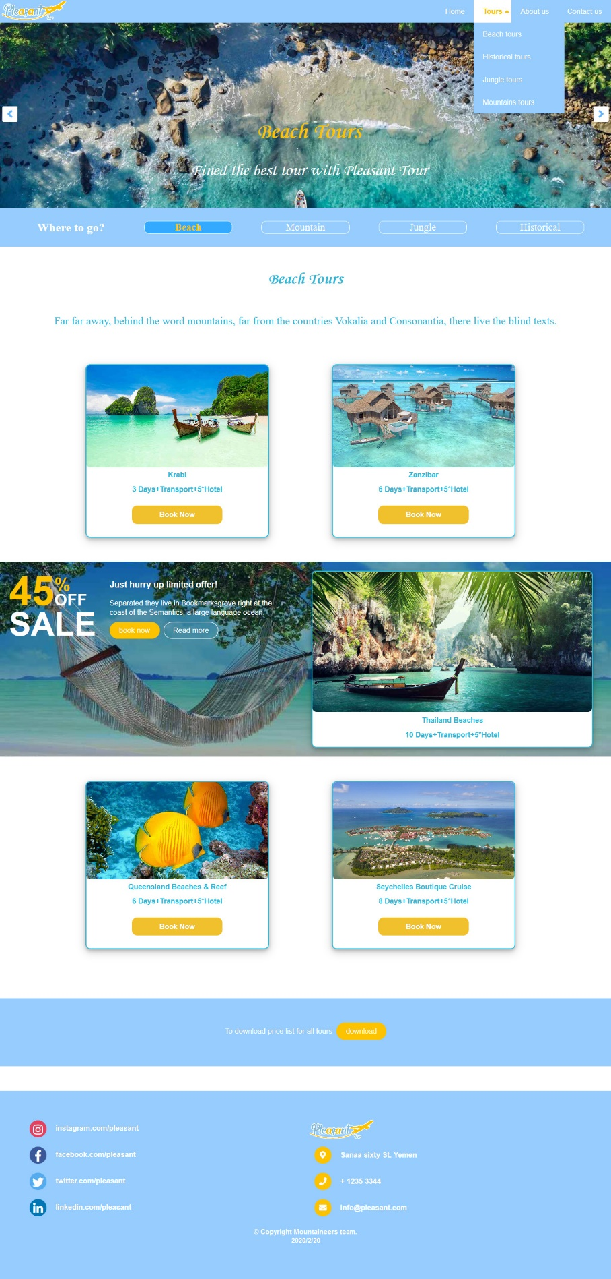When a user selects any product type, a list of products for that product type will be displayed.
3. Itinerary of individual tour products should be displayed on the Web Page along with the title but detailed itinerary should be stored in Individual Word documents which can be downloaded or viewed by the User who wishes to see the same.

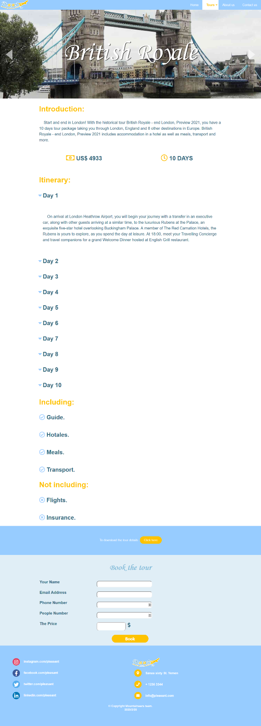­­­­­

1. Price List for all tours should be available for download.

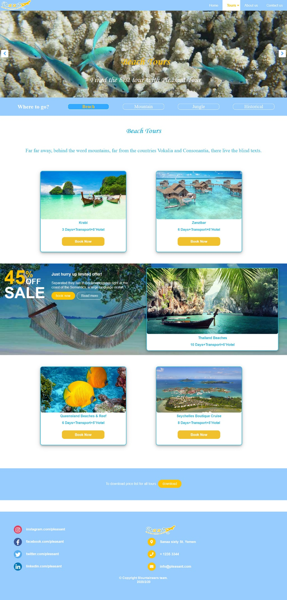

1. There should be a "Contact Us" page which will have the Address of the Company which is as follows and the mail address which when clicked will invoke the local mail client from where they can send an email. Address of the Company should be displayed using Geolocation API (e.g. Google Maps).

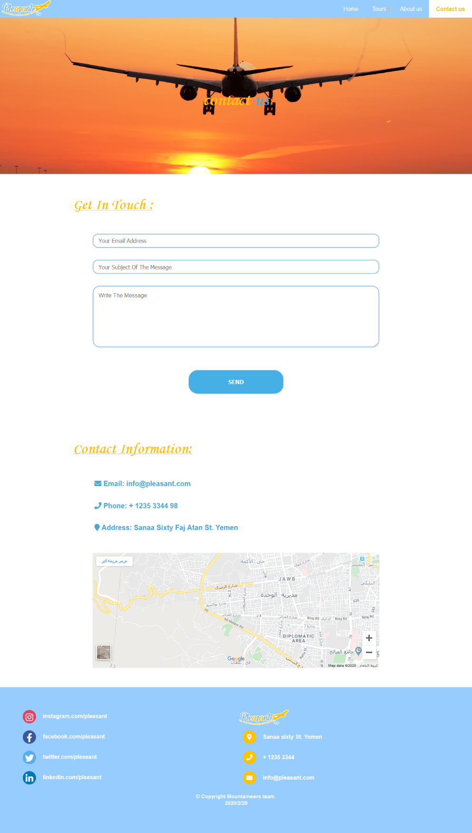

# **Requirement checklist**

|  |  |  |
| --- | --- | --- |
| S.No | Requirements | Statues |
| 1 | The Home Page should be created making use of Frames with a suitable logo. | Completed |
| 2 | The site should display a menu which will contain the options for brief introduction about the various products available, location of the shop and any other information if required. | Completed |
| 3 | The information should be categorized according to different type of products. | Completed |
| 4 | When a user selects any product type, a list of products for that product type will be displayed. | Completed |
| 5 | Itinerary of individual tour products should be displayed on the Web Page along with the title but detailed itinerary should be stored in Individual Word documents which can be downloaded or viewed by the User who wishes to see the same. | Completed |
| 6 | Price List for all tours should be available for download. | Completed |
| 7 | A ‘Contact Us’ page containg the address of the company and the emailing address. | Completed |

# **Task Sheet**

|  |  |  |  |  |  |
| --- | --- | --- | --- | --- | --- |
| S.No | Task | Start Date | End Date | Performed By | Status |
| 1 | Requirement Analysis | 24 Mar | 27 Mar | Mohammed Qa’atabi,  Hesham Noaman,  Maryam Hajeb,  Osama Al-koli,  Ali Aljawfi. | Completed |
| 2 | Information Gathering | 27 Mar | 1  Apr | Maryam Hajeb | Completed |
| 3 | Graphic Designing | 28 Mar | 2  Apr | Maryam Hajeb | Completed |
| 4 | Website Design | 27 Mar | 1  Apr | Hesham Noaman | Completed |
| 5 | Coding | 2  Apr | 22  Apr | Mohammed Qa’atabi,  Hesham Noaman,  Maryam Hajeb,  Osama Al-koli,  Ali Aljawfi. | Completed |
| 6 | Draft Document | 23  Apr | 26  Apr | Hesham Noaman,  Osama Al-koli. | Completed |
| 7 | Prepare Documentation | 25  Apr | 29  Apr | Maryam Hajeb,  Ali Aljawfi. | Completed |
| 8 | Testing & Reviewing | 28  Apr | 1  May | Hesham Noaman | Completed |

# **Checklist of Validations**

|  |  |
| --- | --- |
| Option | Validated |
| Do all text links lead to the appropriate Web site? | Yes |
| Do all the image links lead to the appropriate Web site? | Yes |
| Are all the images and links clearly visible on the page? | Yes |
| Have the images been localized based on the contract signed with the client? | Yes |
| Is the Web page opening properly in all the tested Web browsers? | Yes |
| Is the Web page taking too long to load? | No |
| Is the navigation sequence correct through all the Web pages on the site? | Yes |
| Is the JavaScript code working as expected in all click events? | Yes |

# **Submission checklist**

|  |  |  |  |
| --- | --- | --- | --- |
| S.No | Particulars | YES/NO | Comments |
| 1 | Are there any broken links? | No | - |
| 2 | Are all hyperlinks working? | Yes | - |
| 3 | Are there any spelling mistakes? | No | - |
| 4 | Does the site follow themes? | Yes | - |
| 5 | Are all the web compnents working? | Yes | All web componenets work on suitable configurations |
| 6 | Is site Browser compatible? | Yes | Best results are viewed on Mozilla Firefox and Opera |
| 7 | Has an Iframe been used? | Yes | - |
| 8 | Do you use jQuery in the project? | Yes | - |
| 9 | Do you use addional jQuery libraries in the project? | Yes | jQuery UI and Owl Carousel plugin are used. |
| 10 | Are all the users able to view the images and links? | Yes | - |
| 11 | Have all the pages been properly integrated and are completely functional? | Yes | - |
| 12 | Is the application user-friendly? | Yes | - |
| 13 | Is the Web site launching correctly in the  browser? | Yes | - |

# **Source Code**

# **Home page:**

<!DOCTYPE html>

<html>

<head>

<title>Pleasant Tour</title>

<meta charset="UTF-8">

<meta name="viewport" content="width=device-width, initial-scale=1">

<link rel="stylesheet" href="css/Home.css" >

<link rel="stylesheet" href="css/owl.carousel.min.css">

<link rel="stylesheet" href="css/owl.theme.default.css">

<link rel="stylesheet" href="css/animate.css" >

<!-- font library -->

<link rel="stylesheet" href="font/font.css" >

<!-- library for icon -->

<link rel="stylesheet" href="css/fontawesom_all.css">

<!-- pleasant tour icon -->

<link href="img/icon.png" type="image/x-icon" rel="shortcut icon"/>

<!-- javaScript library -->

<script src="js/jquery-3.1.1.min.js"></script>

<script src="js/owl.carousel.min.js"></script>

</head>

<body>

<header >

<!-- logo section -->

<div class="logo" >

<a href="index.html">

<img src="img/logo.png" alt="logo" width="150px" ></a>

</div>

<!-- Navegation section -->

<nav>

<ul>

<li ><a class="active" href="index.html">Home</a></li>

<li class="sub-menu" ><a href="#" >Tours</a>

<ul>

<li><a href="Beach-tour.html" >Beach tours</a></li>

<li><a href="Historical-tour.html" >Historical tours</a></li>

<li><a href="Jungle-tour.html" >Jungle tours</a></li>

<li><a href="Mountains-tour.html" >Mountains tours</a></li>

</ul>

</li>

<li><a href="about-us.html" >About us</a></li>

<li><a href="contact-us.html" >Contact us</a></li>

</ul>

</nav>

<div class="menu-toggel"><i class="fa fa-bars" aria-hidden="true"></i></div>

</header>

<script src="js/function_nav.js"></script>

<!--*** the end of logo and nav section ***-->

<!--*** start of image slider ***-->

<section class="image-slider">­

<div class="owl-carousel owl-theme">

<div class="slider over" style="background-image: url(Content/BeachTours/Zanzibar/img/2.jpg);">

<div class="container">

<div class="owl-slide-text">

<h2>Fined the best tour with Pleasant Tour</h2>

</div>

</div>

</div>

<div class="slider" style="background-image: url(Content/HistoricalTour/BritishRoyale/img/3.jpg);">

<div class="container">

<div class="owl-slide-text">

<h2>Fined the best tour with Pleasant Tour</h2>

</div>

</div>

</div>

<div class="slider" style="background-image: url(Content/JungleTours/JunglePuertoMaldonado/img/2.jpg);">

<div class="container">

<div class="owl-slide-text">

<h2>Fined the best tour with Pleasant Tour</h2>

</div>

</div>

</div>

<div class="slider" style="background-image: url(Content/MountainsTours/EverestViewTrek/img/1.jpg);">

<div class="container">

<div class="owl-slide-text">

<h2>Fined the best tour with Pleasant Tour</h2>

</div>

</div>

</div>

</div>

</section>

<script src="js/image-slider-function.js"></script>

<!--*** end of image slider ***-->

<!--*** start of Where to go section ***-->

<section>

<div class="continer-where">

<div class="where">Where to go?</div>

<a href="Beach-tour.html" class="tour">Beach</a>

<a href="Mountains-tour.html" class="tour">Mountain</a>

<a href="Jungle-tour.html" class="tour">Jungle</a>

<a href="Historical-tour.html" class="tour">Historical</a>

</div>

</section>

<!--*** end of Where to go section ***-->

<!--*** Start of card section ***-->

<!-- Beach Tours -->

<h2 class="tour_type">Beach Tours</h2>

<!-- the first card -->

<div class="tour_card1">

<img class="card-img" src="Content/BeachTours/Krabi/img/1.jpg"

alt="beach" />

<div class="card_details"> Krabi <br /> <br /> 3 Days+Transport+5*Hotel

</div>

<a href="html/Tour/Krabi.html" class="button">Book Now </a>

</div>

<!-- the second card -->

<div class="tour_card2">

<img class="card-img" src="Content/BeachTours/Zanzibar/img/4.jpg" alt="beach" />

<div class="card_details">

Zanzibar<br /><br />

6 Days+Transport+5*Hotel

</div>

<a href="html/Tour/Zanzibar.html" class="button">Book Now </a>

</div>

<!-- SEE MORE section -->

<a href="Beach-tour.html" class="see_more"> See More </a>

<hr />

<!-- Mountains Tours -->

<h2 class="tour_type">Mountains Tours</h2>

<!-- the first card -->

<div class="tour_card1">

<img class="card-img" src="Content/MountainsTours/AtlasMountains/img/4.jpg"

alt="Mountains" />

<div class="card_details"> Atlas Mountains <br /> <br /> 5 Days+Transport+5*Hotel

</div>

<a href="html/Tour/AtlasMountains.html" class="button">Book Now </a>

</div>

<!-- the second card -->

<div class="tour_card2">

<img class="card-img" src="Content/MountainsTours/EverestViewTrek/img/2.jpg" alt="Mountains" />

<div class="card_details">

Everest View Trek <br /><br />

15 Days+Transport+5*Hotel

</div>

<a href="html/Tour/EverestViewTrek.html" class="button">Book Now </a>

</div>

<!-- SEE MORE section -->

<a href="Mountains-tour.html" class="see_more"> See More </a>

<hr />

<!-- Historical Tours -->

<h2 class="tour_type">Historical Tours</h2>

<!-- the first card -->

<div class="tour_card1">

<img class="card-img" src="Content/HistoricalTour/RajToTaj/img/2.jpg" alt="Historical" />

<div class="card_details"> Raj to Taj & Beyond<br /><br />

5 Days+Transport+5*Hotel

</div>

<a href="html/Tour/RajToTaj.html" class="button">Book Now </a>

</div>

<!-- the second card -->

<div class="tour_card2">

<img class="card-img" src="Content/HistoricalTour/SriLankaCulturalAndAdventureTour/img/1.jpg" alt="Historical" />

<div class="card_details"> Sri Lanka Cultural and Adventure Tour<br /><br />

10 Days+Transport+5*Hotel

</div>

<a href="html/Tour/SriLankaCulturalAndAdventureTour.html" class="button">Book Now </a>

</div>

<!-- SEE MORE section -->

<a href="Historical-tour.html" class="see_more"> See More </a>

<!--*** end of card section ***-->

<!-- *** start of testimomial section ***-->

<section class="testmontial">

<div class="wrap owl-carousel owl-theme" id="testimonial_slider" >

<div class="testimo-content" >

<div class="img-contener" >

<img src="img/person_1.jpg" alt="client image" >

</div>

<div class="testimo-review" >

<blockquote>

<i class="fas fa-quote-left"></i>

Lorem Ipsum is simply dummy text of the printing and typesetting industry. Lorem Ipsum has been the industry's standard dummy text ever since the 1500s, when an unknown printer took a galley of type and scrambled.

<i class="fas fa-quote-right"></i>

</blockquote>

<div class="auther">

<strong>Hesham</strong>

<small>Web Devloper</small>

</div>

</div>

</div>

<div class="testimo-content" >

<div class="img-contener" >

<img src="img/person_2.jpg" alt="client image" >

</div>

<div class="testimo-review" >

<blockquote>

<i class="fas fa-quote-left"></i>

Lorem Ipsum is simply dummy text of the printing and typesetting industry. Lorem Ipsum has been the industry's standard dummy text ever since the 1500s, when an unknown printer took a galley of type and scrambled.

<i class="fas fa-quote-right"></i>

</blockquote>

<div class="auther">

<strong>Osama</strong>

<small>Android Devloper</small>

</div>

</div>

</div>

<div class="testimo-content" >

<div class="img-contener" >

<img src="img/person_3.jpg" alt="client image" >

</div>

<div class="testimo-review" >

<blockquote>

<i class="fas fa-quote-left"></i>

Lorem Ipsum is simply dummy text of the printing and typesetting industry. Lorem Ipsum has been the industry's standard dummy text ever since the 1500s, when an unknown printer took a galley of type and scrambled.

<i class="fas fa-quote-right"></i>

</blockquote>

<div class="auther">

<strong>Ali</strong>

<small>Games Devloper</small>

</div>

</div>

</div>

<div class="testimo-content" >

<div class="img-contener" >

<img src="img/person_4.jpg" alt="client image" >

</div>

<div class="testimo-review" >

<blockquote>

<i class="fas fa-quote-left"></i>

Lorem Ipsum is simply dummy text of the printing and typesetting industry. Lorem Ipsum has been the industry's standard dummy text ever since the 1500s, when an unknown printer took a galley of type and scrambled.

<i class="fas fa-quote-right"></i>

</blockquote>

<div class="auther">

<strong>Mohammed</strong>

<small>Front End Devloper</small>

</div>

</div>

</div>

</div>

</section>

<script src="js/testimonial-function.js"></script>

<!-- *** end of testimomial section ***-->

<!--*** start of card section ***-->

<!-- Jungle Tours -->

<h2 class="tour_type">Jungle Tours</h2>

<!-- the first card -->

<div class="tour_card1">

<img class="card-img" src="Content/JungleTours/AmazonJungle/img/3.jpg"

alt="Jungle" />

<div class="card_details"> Amazon Jungle <br /> <br /> 5 Days+Transport+5*Hotel

</div>

<a href="html/Tour/AmazonJungle.html" class="button">Book Now </a>

</div>

<!-- the second card -->

<div class="tour_card2">

<img class="card-img" src="Content/JungleTours/IquitosJungle/img/3.jpg" alt="Jungle" />

<div class="card_details"> Iquitos Jungle Tour <br /> <br /> 5 Days+Transport+5*Hotel

</div>

<a href="html/Tour/IquitosJungle.html" class="button">Book Now </a>

</div>

<!-- SEE MORE section -->

<a href="Jungle-tour.html" class="see_more"> See More </a>

<!--*** end of card section ***-->

<!--*** start of footer ***-->

<footer>

<div class="footer-left" >

<div>

<i class="fab fa-instagram"></i>

<a href="https://www.instagram.com/pleasant.tour.2020">

instagram.com/pleasant.tour.2020</a>

</div>

<div>

<i class="fab fa-facebook-f"></i>

<a href="https://www.facebook.com/pleasant.tour.2020">

facebook.com/pleasant.tour.2020</a>

</div>

<div>

<i class="fab fa-twitter"></i>

<a id="twitter" href="https://www.twitter.com/pleasant.tour.2020">

twitter.com/pleasant.tour.2020</a>

</div>

<div>

<i class="fab fa-linkedin-in"></i>

<a id="linkedin" href="https://www.twitter.com/pleasant.tour.2020">

linkedin.com/pleasant.tour.2020</a>

</div>

</div>

<div class="footer-right" >

<div class="logo">

<img src="img/logo.png" alt="logo" width="150px" >

</div>

<div>

<i class="fas fa-map-marker-alt"></i>

<p>Sanaa sixty St. Yemen</p>

</div>

<div>

<i class="fas fa-phone"></i>

<p>+ 1235 3344</p>

</div>

<div>

<i class="fas fa-envelope"></i>

<p><a href="https://info@pleasant.com">info@pleasant.com</a></p>

</div>

</div>

<div class="copy-right">

<p>&#169; Copyright Mountaineers team. <br> 2020/2/20</p>

</div>

</footer>

<!--*** end of footer ***-->

</body>

</html>

# **Home page ( Style ) :**

/*--Genral style--*/

* { -wibkit-box-sizing: border-box; -moz-box-sizing: border-box; -o-box-sizing: border-box; box-sizing: border-box; list-style: none;}

body { margin: 0;padding: 0;font-family: Arial, Tahoma;overflow-x: hidden;}

a { color: #fff; transition: 0.5s; -webkit-transition: 0.5s; -o-transition: 0.5s; transition: 0.5s; text-decoration: none;}

/*--header and navigation style--*/

header { position: absolute; top: 0; left: 0; padding: 0 100px; background:rgb(151,204,255); width: 100%; z-index: 3; margin: 0; padding: 0; font-family: sans-serif; }

header .logo { height: 50px; float: left; }

header nav { float: right; z-index: 1000; }

header nav ul { margin: 0; padding: 0; display:flex; }

header nav ul li { list-style: none; position: relative; }

header nav ul li.sub-menu:*before* { content: "\f0d7"; font-family: "Font Awesome 5 free" ; position: absolute; line-height: 50px; color: #FEC300; right: 5px; font-weight: bold; }

header nav ul li.active.sub-menu:*before* { content: "\f0d8"; font-weight: bold; }

header nav ul li ul { position: absolute; left: 0; background: rgb(151,204,255); display: none; }

/*can be ==> header nav ul li:hover ul */

header nav ul li.active ul { display: block;}

header nav ul li ul li { display: block; width: 200px; }

header nav ul li a { height: 50px; line-height: 50px; padding: 0 20px; display: block; }

header nav ul li a:*hover*, header nav ul li a.active { color: #FEC300; font-weight: bold; background-color: white; }

.menu-toggel { color: white; float: right; line-height: 50px; font-size: 24px; cursor: pointer; display: none; }

/* mobile and tablet version */

*@media (max-width:991px)* {

header { padding: 0 20px; }

.menu-toggel { display: block;}

header nav { position: absolute; width: 100%; height: calc(100vh - 50px); background: rgb(151,204,255); top: 50px; left: -100%; transition: 0.5s;}

header nav.active { left: 0;}

header nav ul { display: block; text-align: center; }

header nav ul li a { border-bottom: 1px solid rgba(0,0,0,.2);}

/* and also can be ==> header nav ul li:hover ul */

header nav ul li.active ul { position: relative; background: #4da6ff;}

header nav ul li ul li { width: 100%;}

}

/*--Img slider section --*/

.slider { background-size: cover; background-position: center; background-repeat: no-repeat; overflow-x: hidden; position: relative; height: 70vh; font-family: 'mnglwritingotf', serif ; }

.over::*before* { position: absolute; content: ""; background-color: rgba(0, 29, 56,.1); top: 0; left: 0; width: 100%; height: 100%; z-index: 1; }

.owl-slide-text { position: absolute; top: 50%; width: 100%; text-align: center; z-index: 3; }

.container .owl-slide-text h2 { color: #FEC300; font-size: 2.8em *!important*;}

.container .owl-slide-text p { color: #FFF; font-size: 2.1em; }

.fa-angle-right ,.fa-angle-left { font-size: 1.9em; width: 20px; height: 20px; color: #66b3ff; }

.fa-angle-left:*hover* ,.fa-angle-right:*hover* { color: #FEC300;}

*@media (max-width: 750px)* {

.container .owl-slide-text h2 { font-size:2em *!important*; }

.container .owl-slide-text p { font-size:1.4em; }

.fa-angle-right , .fa-angle-left { display:none; }

.owl-theme .owl-nav [class*='owl-'] { display:none *!important*; }

}

/*--where to go section--*/

.continer-where { display: flex; background:rgb(151,204,255); color: white; width: 100vw; padding: 2% ; text-align: center; max-width:100%; font-family: Arail ; }

.where { width: 20%; margin: 0; font-size: 1.63em; font-weight: bold; }

a.tour { margin :auto ; font-size: 1.4em; width: 15%; text-align: center; border: 1px solid #FFF; border-radius: 0.8vw; display: block; }

a.tour:hover , a.active-link { background:#3Af; font-weight: bold; color: #fEC300; }

*@media (max-width: 800px)* {

.continer-where { display: block;}

.where { width: 100%; padding: 0; font-size: 1.5em; }

a.tour { margin:2% auto; width: 220px; font-size: 1.3em; }

}

/*--card section--*/

.tour_type { width:100%; text-align:center; font-family: 'mnglwritingotf', serif ; color:#2EB9D9; font-size:2em; margin: 4% 0; }

.tour-caption { width:100%; text-align:center; font-family: Arail ; color:#2EB9D9; font-size:1.5em; padding: 0 8% ;margin: 4% 0 2% 0 ; }

.tour_card1 ,.tour_card2 { border:2px solid #2EB9D9; width:30%; border-radius: 10px; display:inline-block;

box-shadow: 0 4px 8px 0 rgba(0, 0, 0, 0.2), 0 6px 20px 0 rgba(0, 0, 0, 0.19); }

.tour_card1 { margin: 4% auto 4% 14% ;}

.tour_card2 { margin: 4% 14% 4% 10%;}

img.card-img { width:100%; height:50%; border-radius: 8px; }

.card_details { margin: 1% auto 3% auto; border:none; width:100%; text-align:center; font-weight:bold; color:#2EB9D9; font-size:1em; line-height: 1;}

a.button:*hover* , a.see_more:*hover* ,.right-offer .btn:*hover*,.download-tour .btn:*hover*,.btn:*hover* {

box-shadow: 0 4px 8px 0 #2EB9D9, 0 6px 20px 0 #2EB9D9; }

.button { border:none; margin:7% 25%; padding:2.5%; border-radius: 12px; background-color:#F0C02D; text-align:center; font-weight: bold; font-size:1em; display: block; }

.see_more { margin:5% 42%; adding:0.5% 0.25%; border-radius: 12px; background-color:#2EB9D9; text-align:center; font-weight: bold; font-size:1em; display: block; }

@media (max-width: 800px) {

.tour_card1 ,.tour_card2 { display: block; width: 60%; margin: 5% 19.5%; }

.button { margin:5% 25%;}

.see_more { margin:5% 38.5%; padding:0.5% 0.25%; }

}

*@media (max-width: 750px)* {

.tour_type { font-size:1.5em; }

}

*@media (max-width: 400px)* {

.tour_card1 ,.tour_card2 { display: block; width: 80%; margin: 5% 9.5%; }

}

/*--testimonial slider--*/

section.testmontial { box-sizing: content-box; width: 100%; height: 100%; }

section.about-testmontial { margin:7vh 0; }

.testimo-content { position: relative; padding: 0; margin: 0; background-color: rgb(151,204,255); color: #fff; text-align: center; }

.img-contener { max-width: 100%; height: 200px; width:200px; display: inline-block; border: 5px solid #FEC300; margin-bottom: 10px; border-radius: 50%; }

.img-contener img { width: 100%; height: 100%; border-radius: 50%; border:4px solid #fff; margin: 1; }

.testimo-review { font-family: tahoma; padding: 1vw 4vw; }

.testimo-review blockquote { display: block; font-size: 16px; font-weight: bold; line-height: 1.5em; position: relative; }

.testimo-review .auther strong { font-size: 18px; font-weight: bold; display: inline-block; line-height: 1.4em;color: #FEC300; letter-spacing: 1; text-transform: uppercase; }

.testimo-review .auther small { font-size: 16px;}

*@media (max-width: 500px)* {

.img-contener { width: 40vw; height: 40vw; }

}

/*--limited offer section--*/

.offer-box { z-index: 0; background-size: cover; background-position: center; background-repeat: no-repeat; position: relative; padding: 20px;}

.offer-box::before { background-color: rgba(0, 29, 56,.3); z-index: -1; }

.box-container { display: flex;}

.box-container h2 , .box-container p , .box-container h3 { margin-bottom: 20px;}

.offer-text { display: table;}

.offer-text .left-text { text-align: left; display: table-cell; vertical-align: top; }

.offer-text .left-text .sale-box .sale-box-top { display: inline-block; position: relative; }

.offer-text .left-text .sale-box .sale-box-top .num { font-weight: 700; font-size: 90px; margin: 0; line-height: 1; display: inline-block; color: #fEC300 ; }

.offer-text .left-text .sale-box .sale-box-top .percent { font-weight: 700; font-size: 40px; position: absolute; line-height: 1; top: 10px; left: 100%; display: block; color: #fEC300; }

.offer-text .left-text .sale-box .sale-box-top .off { color: #fff; font-size: 36px; text-transform: uppercase; position: absolute; bottom: 8px; left: 100%; display: block; line-height: 1; font-weight: 700; }

.offer-text .left-text .sale-box .text-sale { font-size: 72px; color: #fff; text-transform: uppercase; line-height: 55px; margin: 0; font-weight: 700; }

.offer-text .right-offer { padding: 0 30px;}

.offer-text .right-offer { color: #fff; font-weight: 400;}

.offer-text .right-offer .btn , .download-tour .btn , .btn { margin-right: 4px; margin-bottom: 4px; font-size: 16px; font-weight: 400; border-­: 8px 20px; }

.offer-text .right-offer .read { border: 1px solid #fff ; color: #fff ; }

.read:hover , .read:active , .read:focus { background-color: #fEC300; }

.offer-text .right-offer .book , .download-tour .btn, button.btn { background-color: #fEC300; color: #fff; border : 1px solid #fEC300; }

*@media (max-width:950px)* {

.box-container { display: block; }

}

*@media (max-width:768px)* {

.box-container { margin-bottom: 4em; }

.offer-text .left-text { display: table; margin-bottom: 3em; }

.offer-text .right-offer { padding: 0;}

}

/*----card----*/

.offer-card { width: 70%; margin: auto 20px; }

.offer-card .card { width:100%; margin: auto; background-color: #fff; }

*@media (max-width:950px)* {

.offer-card { margin: 40px auto; padding-left: 15px; padding-right: 15px; width: 95%; }

}

/*--download tour section--*/

.download-tour { background-color: rgb(151,204,255); margin: 4% 0 ; padding: 4%; text-align: center; color: #fff ; width: 100%; }

.download-tour p { display: inline-block; margin: 5px; }

.download-tour a { display: inline-block;}

/*--start style for about us page--*/

/*--Img section--*/

.imgSection { background: url("../img/bradcam3.png") no-repeat fixed center; background-size: cover; height:50vh; text-align: center; margin-top: 50px; padding-bottom: 0; overflow:hidden; z-index: 1; font-family: 'mnglwritingotf', serif ;}

.imgSection h1 { color: #fec300; line-height: 40vh; font-size: 2.8em *!important*;}

.imgSection p { color: #fff; margin: 0; font-size: 2.1em; position: relative; top: -18vh; z-index:2; }

*@media (max-width:750px)* {

.imgSection h1 { font-size:2em *!important*;}

.imgSection p { font-size:1.4em; top: -19vh; }

}

/*--Content section--*/

.content { margin:7vh 5vw;}

.content h2 { color: #fec300; font-family: 'mnglwritingotf', serif ; font-size: 38px; line-height: 1; }

.content p { color: #82bcda; margin: 0; font-size: 20px; text-indent:2.5%; line-height: 150%; }

.content .img { background: url(../img/about.jpg) no-repeat scroll center; background-size: cover; padding-left: 3vw; text-align: center; height: 50vh; }

.content .story { padding-left: 4vw;}

*@media (max-width:800px)* {

.content { margin-left: 8vw; margin-right: 8vw; padding-left: 8vw; padding-right: 8vw; text-align: center; float: none; }

.content .story { margin: 0; padding: 0; text-align: center; width: 100%; }

.content .img { width:50vw; margin: 3vh 10% ; }

.content h2 { font-size: 30px; text-align: center; width: 100%; }

.content p { font-size: 18px; top: -19vh; width: 100%; }

}

*@media (max-width:450px)* {

.content .img { width:60vw; height: 35vh; }

}

/*--end style for about us page--*/

/*--Footer section--*/

footer { bottom: 0; background-color: rgb(151,204,255); color: white ; width: 100%; text-align: left; font: bold 16px sans-serif; padding: 55px 50px; }

footer .footer-left , footer .footer-right { display: inline-block;}

footer .footer-left { width: 50%;}

footer .footer-right { width: 40%;}

footer .footer-left i , footer .footer-right i { color: #ffffff; font-size: 25px; width: 38px; height: 38px; border-radius: 50%; text-align: center; line-height: 42px; margin: 10px 15px; vertical-align: middle; }

footer .footer-left i.fa-instagram { background-color: #e4405f;}

footer .footer-left i.fa-facebook-f { background-color: #3b5999;}

footer .footer-left i.fa-twitter { background-color: #55acee;}

footer .footer-left i.fa-linkedin-in { background-color: #0077b5;}

footer .footer-right i { font-size: 17px; line-height: 38px; background-color: #FEC300; }

footer .footer-right p { display: inline-block; color: #fff; vertical-align: middle; margin:0; }

footer .footer-right p a , footer .footer-left a { color: #fff; text-decoration: none; }

footer .copy-right { display: block; color: #fff; text-align: center; font-size: 15px; font-weight: bold; margin-bottom: 20px; }

*@media (max-width: 710px)* {

footer { font: bold 14px sans-serif;}

footer .footer-left , footer .footer-right { display: block; width: 100%; margin-bottom: 40px; text-align: center; }

footer .footer-left #twitter { margin-right: 25px;}

footer .footer-left #linkedin { margin-right: 13px;}

}

# **About us:**

<!DOCTYPE html>

<html>

<head>

<title>about us</title>

<meta charset="UTF-8">

<meta name="viewport" content="width=device-width, initial-scale=1">

<link rel="stylesheet" type="text/css" href="css/grid.css"/>

<link rel="stylesheet" href="css/Home.css" >

<link rel="stylesheet" href="css/owl.carousel.min.css">

<link rel="stylesheet" href="css/owl.theme.default.css">

<!-- font library -->

<link rel="stylesheet" href="font/font.css" >

<!-- library for icon -->

<link rel="stylesheet" href="css/fontawesom_all.css">

<!-- pleasant tour icon -->

<link href="img/icon.png" type="image/x-icon" rel="shortcut icon"/>

<!-- javaScript library -->

<script src="js/jquery-3.1.1.min.js"></script>

<script src="js/owl.carousel.min.js"></script>

</head>

<body>

<header >

<!-- logo section -->

<div class="logo" >

<a href="indwx.html">

<img src="img/logo.png" alt="logo" width="150px" ></a>

</div>

<!-- Navegation section -->

<nav>

<ul>

<li ><a href="index.html">Home</a></li>

<li class="sub-menu" ><a href="#" >Tours</a>

<ul>

<li><a href="Beach-tour.html" >Beach tours</a></li>

<li><a href="Historical-tour.html" >Historical tours</a></li>

<li><a href="Jungle-tour.html" >Jungle tours</a></li>

<li><a href="Mountains-tour.html" >Mountains tours</a></li>

</ul>

</li>

<li><a class="active" href="about-us.html" >About us</a></li>

<li><a href="contact-us.html" >Contact us</a></li>

</ul>

</nav>

<div class="menu-toggel"><i class="fa fa-bars" aria-hidden="true"></i></div>

</header>

<script src="js/function_nav.js"></script>

<!--*** the end of logo and nav section ***-->

<!--*** start of image section***-->

<div class="row imgSection">

<h1>About US</h1>

<p>Find the best tours with <br>Pleasant Tour</p>

</div>

<!--*** start of image section***-->

<!--*** start of content section***-->

<div class="row content">

<!--*** start of story section ***-->

<div class="col span-1-of-2 story">

<h2>Our story</h2>

<p>Pleasant Tour is a touring company that has various tour products. It was estaplished in November 2016. It aim to give clients the best traveling experience with the cheapest cost and the most interesting tours.</p>

</div>

<!--*** end of story section ***-->

<!--*** start of image section***-->

<div class="col span-1-of-2 img"></div>

<!--*** end of image section***-->

</div>

<!--*** end of content section***-->

<!-- ************** start of testimomial section **************-->

<section class="testmontial about-testmontial">

<div class="wrap owl-carousel owl-theme" id="testimonial_slider" >

<div class="testimo-content" >

<div class="img-contener" >

<img src="img/person_1.jpg" alt="client image" >

</div>

<div class="testimo-review" >

<blockquote>

<i class="fas fa-quote-left"></i>

Lorem Ipsum is simply dummy text of the printing and typesetting industry. Lorem Ipsum has been the industry's standard dummy text ever since the 1500s, when an unknown printer took a galley of type and scrambled.

<i class="fas fa-quote-right"></i>

</blockquote>

<div class="auther">

<strong>Hesham</strong>

<small>Web Devloper</small>

</div>

</div>

</div>

<div class="testimo-content" >

<div class="img-contener" >

<img src="img/person_2.jpg" alt="client image" >

</div>

<div class="testimo-review" >

<blockquote>

<i class="fas fa-quote-left"></i>

Lorem Ipsum is simply dummy text of the printing and typesetting industry. Lorem Ipsum has been the industry's standard dummy text ever since the 1500s, when an unknown printer took a galley of type and scrambled.

<i class="fas fa-quote-right"></i>

</blockquote>

<div class="auther">

<strong>Osama</strong>

<small>Android Devloper</small>

</div>

</div>

</div>

<div class="testimo-content" >

<div class="img-contener" >

<img src="img/person_3.jpg" alt="client image" >

</div>

<div class="testimo-review" >

<blockquote>

<i class="fas fa-quote-left"></i>

Lorem Ipsum is simply dummy text of the printing and typesetting industry. Lorem Ipsum has been the industry's standard dummy text ever since the 1500s, when an unknown printer took a galley of type and scrambled.

<i class="fas fa-quote-right"></i>

</blockquote>

<div class="auther">

<strong>Ali</strong>

<small>Games Devloper</small>

</div>

</div>

</div>

<div class="testimo-content" >

<div class="img-contener" >

<img src="img/person_4.jpg" alt="client image" >

</div>

<div class="testimo-review" >

<blockquote>

<i class="fas fa-quote-left"></i>

Lorem Ipsum is simply dummy text of the printing and typesetting industry. Lorem Ipsum has been the industry's standard dummy text ever since the 1500s, when an unknown printer took a galley of type and scrambled.

<i class="fas fa-quote-right"></i>

</blockquote>

<div class="auther">

<strong>Mohammed</strong>

<small>Front End Devloper</small>

</div>

</div>

</div>

</div>

</section>

<script src="js/testimonial-function.js"></script>

<!-- ************** End of testimomial section **************-->

<!--*** start of footer ***-->

<footer>

<div class="footer-left" >

<div>

<i class="fab fa-instagram"></i>

<a href="https://www.instagram.com/pleasant.tour.2020">

instagram.com/pleasant.tour.2020</a>

</div>

<div>

<i class="fab fa-facebook-f"></i>

<a href="https://www.facebook.com/ pleasant.tour.2020">

facebook.com/pleasant.tour.2020</a>

</div>

<div>

<i class="fab fa-twitter"></i>

<a id="twitter" href="https://www.twitter.com/pleasant.tour.2020">

twitter.com/pleasant.tour.2020</a>

</div>

<div>

<i class="fab fa-linkedin-in"></i>

<a id="linkedin" href="https://www.twitter.com/pleasant.tour.2020">

linkedin.com/pleasant.tour.2020</a>

</div>

</div>

<div class="footer-right" >

<div class="logo">

<img src="img/logo.png" alt="logo" width="150px" >

</div>

<div>

<i class="fas fa-map-marker-alt"></i>

<p>Sanaa sixty St. Yemen</p>

</div>

<div>

<i class="fas fa-phone"></i>

<p>+ 1235 3344</p>

</div>

<div>

<i class="fas fa-envelope"></i>

<p><a href="https://info@pleasant.com">info@pleasant.com</a></p>

</div>

</div>

<div class="copy-right">

<p>&#169; Copyright Mountaineers team. <br> 2020/2/20</p>

</div>

</footer>

<!--*** end of footer ***-->

</body>

</html>

# **Contact us:**

<!DOCTYPE html>

<html lang="en">

<head>

<title>Contact Us</title>

<meta charset="UTF-8">

<meta name="viewport" content="width=device-width, initial-scale=1">

<link rel="stylesheet" href="css/Home.css" >

<link rel="stylesheet" href="css/contact.css" >

<!-- font library -->

<link rel="stylesheet" href="font/font.css" >

<!-- library for icon -->

<link rel="stylesheet" href="css/fontawesom_all.css">

<!-- pleasant tour icon -->

<link href="img/icon.png" type="image/x-icon" rel="shortcut icon"/>

<!-- javaScript library -->

<script src="js/jquery-3.1.1.min.js"></script>

<!-- HTML5 shim and Respond.js IE8 support of HTML5 elements and media queries -->

<!--[if lt IE 9]>

<script src="https://oss.maxcdn.com/libs/html5shiv/3.7.0/html5shiv.js"></script>

<script src="https://oss.maxcdn.com/libs/respond.js/1.4.2/respond.min.js"></script>

<![endif]-->

</head>

<body>

<header >

<!-- logo section -->

<div class="logo" >

<a href="index.html">

<img src="img/logo.png" alt="logo" width="150px" ></a>

</div>

<!-- Navegation section -->

<nav>

<ul>

<li ><a href="index.html">Home</a></li>

<li class="sub-menu" ><a href="#" >Tours</a>

<ul>

<li><a href="Beach-tour.html" >Beach tours</a></li>

<li><a href="Historical-tour.html" >Historical tours</a></li>

<li><a href="Jungle-tour.html" >Jungle tours</a></li>

<li><a href="Mountains-tour.html" >Mountains tours</a></li>

</ul>

</li>

<li><a href="about-us.html" >About us</a></li>

<li><a class="active" href="contact-us.html" >Contact us</a></li>

</ul>

</nav>

<div class="menu-toggel"><i class="fa fa-bars" aria-hidden="true"></i></div>

</header>

<script src="js/function_nav.js"></script>

<!--*** the end of logo and nav section ***-->

<!--***start main image ***-->

<section class="mainimg">

<h2>contact <span>us</span></h2>

</section>

<!--***end main image **-->

<!--***start of content ***-->

<section>

<section class="container">

<!--***start of get in touch section ***-->

<section class="get_in_touch">

<h2>get in touch :</h2>

<form name="contsct_us">

<input type="email" name="Email" placeholder ="Your Email Address">

<input type="text" name="Subject of message" placeholder="Your Subject Of The Message">

<textarea name="Message" placeholder ="Write The Message"></textarea>

<input type="submit" value="SEND">

</form>

</section>

<!--*** end of get in touch section ***-->

<!--***start of contact information section ***-->

<section class="information">

<h2>contact information:</h2>

<section>

<a href="mailto:info@pleasant.com?subject=E-mail from Customer care">

<i class="fa fa-envelope"></i>

Email: info@pleasant.com

</a>

<p>

<i class="fa fa-phone"></i>

phone: + 1235 3344 98

</p>

<p>

<i class="fa fa-map-marker"></i>

address: sanaa sixty faj atan St. Yemen

</p>

<iframe src="https://www.google.com/maps/embed?pb=!1m14!1m12!1m3!1d10883.034182176707!2d44.17809730139592!3d15.336704074142173!2m3!1f0!2f0!3f0!3m2!1i1024!2i768!4f13.1!5e0!3m2!1sar!2s!4v1586249987740!5m2!1sar!2s"

frameborder="0" style="border:0;" allowfullscreen="" aria-hidden="false" tabindex="0"></iframe>

</section>

</section>

<!--***end of contact information section ***-->

</section>

</section>

<!--***end of content ***-->

<!--*** start of footer ***-->

<footer>

<div class="footer-left" >

<div>

<i class="fab fa-instagram"></i>

<a href="https://www.instagram.com/pleasant.tour.2020">

instagram.com/pleasant.tour.2020</a>

</div>

<div>

<i class="fab fa-facebook-f"></i>

<a href="https://www.facebook.com/pleasant.tour.2020">

facebook.com/pleasant.tour.2020</a>

</div>

<div>

<i class="fab fa-twitter"></i>

<a id="twitter" href="https://www.twitter.com/pleasant.tour.2020">

twitter.com/pleasant.tour.2020</a>

</div>

<div>

<i class="fab fa-linkedin-in"></i>

<a id="linkedin" href="https://www.twitter.com/pleasant.tour.2020">

linkedin.com/pleasant.tour.2020</a>

</div>

</div>

<div class="footer-right" >

<div class="logo">

<img src="img/logo.png" alt="logo" width="150px" >

</div>

<div>

<i class="fas fa-map-marker-alt"></i>

<p>Sanaa sixty St. Yemen</p>

</div>

<div>

<i class="fas fa-phone"></i>

<p>+ 1235 3344</p>

</div>

<div>

<i class="fas fa-envelope"></i>

<p><a href="https://info@pleasant.com">info@pleasant.com</a></p>

</div>

</div>

<div class="copy-right">

<p>&#169; Copyright Mountaineers team. <br> 2020/2/20</p>

</div>

</footer>

<!--*** end of footer ***-->

</body>

</html>

# **Contact us (Style):**

/*--- start style for main image---*/

section.mainimg { background: url('../img/main_image.jpeg') no-repeat scroll center; background-size: cover; height: 70vh; text-align: center; position: relative; z-index: 1; }

section.mainimg h2 { color: #FEC300; font-size: 2.8em; font-family: 'mnglwritingotf', serif ; line-height: 1; position: relative; top: 50%; }

.mainimg h2 span { color: #48A9DB; }

*@media (max-width:750px)* {

.mainimg h2{ font-size:2em *!important*;}

}

/*--- end style for main image---*/

/*--- start style for get in touch and information section---*/

.get_in_touch, .information { width: 80vw; margin: auto; }

.get_in_touch h2, .information h2 { margin: 5vw 10vw 4vw 6vw ; text-transform: capitalize; font-weight: bold; text-decoration: underline; color: #FEC300; font-size: 2.4em; font-family: 'mnglwritingotf', serif ; }

form input:*first-of-type*, input:*nth-of-type(2)*, form textarea { display: block; width: 60vw; height: 40px; margin: 2.5vw auto; border: 2px solid #86BCDF; border-radius: 15px; padding-left: 15px; font-size:16px;}

form textarea { height: 175px; border-radius: 20px; padding: 15px; font-family: inherit; }

form input:*last-of-type* { width: 20vw; height: 5vw; margin: 2.2vw 0px 5vw 30vw; border: 1px solid #FFF; border-radius: 2vw; background: #46AFE5; color: #FFF; font-size:16px; font-weight: bold; cursor: pointer; }

*@media (max-width:750px)* {

.get_in_touch h2, .information h2 { font-size: 30px; text-align: center; margin: 5vw 0 ; }

}

*@media (max-width:400px)* {

.get_in_touch h2, .information h2 { font-size: 25px; }

form input:*first-of-type*, input:*nth-of-type(2)* { width: 80vw; height: 40px; margin: 2.5vw auto; padding-left: 5px; }

form textarea { width: 80vw; text-align: center; }

form input:*last-of-type* { width: 26vw; height: 8vw; }

}

/*--- start style for get in touch and information section---*/

/*--- start style for information section---*/

.information section p{text-transform: capitalize }

.information section a, .information section p { display: block; margin: 2vw auto auto 10vw; padding: 5px; color: #48A9DB; font-weight: bold; font-size: 20px; }

section iframe { width: 60vw; height: 50vh; display: block; margin: 4vw auto; }

*@media (max-width:750px)*{

.information section a, .information section p { font-size: 1em; text-align: center; }

section iframe { width: 80vw; margin: 4vw auto; }

}

*@media (max-width:485px)* {

.information section a, .information section p { margin: 10px 0 ; padding: 0;}

}

# **Type pages:**

<!DOCTYPE html>

<html lang="en-US">

<head>

<title>Beach Tours</title>

<meta charset="UTF-8">

<meta name="viewport" content="width=device-width, initial-scale=1">

<link rel="stylesheet" href="css/Home.css" >

<link rel="stylesheet" href="css/owl.carousel.min.css">

<link rel="stylesheet" href="css/owl.theme.default.css">

<link rel="stylesheet" href="css/animate.css" >

<!-- font library -->

<link rel="stylesheet" href="font/font.css" >

<!-- library for icon -->

<link rel="stylesheet" href="css/fontawesom_all.css">

<!-- pleasant tour icon -->

<link href="img/icon.png" type="image/x-icon" rel="shortcut icon"/>

<!-- javaScript library -->

<script src="js/jquery-3.1.1.min.js"></script>

<script src="js/owl.carousel.min.js"></script>

</head>

<body>

<header >

<!-- logo section -->

<div class="logo" >

<a href="index.html">

<img src="img/logo.png" alt="logo" width="150px" ></a>

</div>

<!-- Navegation section -->

<nav>

<ul>

<li ><a href="index.html">Home</a></li>

<li class="sub-menu" ><a class="active" href="#" >Tours</a>

<ul>

<li><a href="Beach-tour.html" >Beach tours</a></li>

<li><a href="Historical-tour.html" >Historical tours</a></li>

<li><a href="Jungle-tour.html" >Jungle tours</a></li>

<li><a href="Mountains-tour.html" >Mountains tours</a></li>

</ul>

</li>

<li><a href="about-us.html" >About us</a></li>

<li><a href="contact-us.html" >Contact us</a></li>

</ul>

</nav>

<div class="menu-toggel"><i class="fa fa-bars" aria-hidden="true"></i></div>

</header>

<script src="js/function_nav.js"></script>

<!--*** the end of logo and nav section ***-->

<!--*** start of image slider ***-->

<section class="image-slider">

<div class="owl-carousel owl-theme">

<div class="slider" style="background-image: url(Content/BeachTours/Krabi/img/4.jpg);">

<div class="container">

<div class="owl-slide-text">

<h2>Beach Tours</h2>

<p>Fined the best tour with Pleasant Tour</p>

</div>

</div>

</div>

<div class="slider over" style="background-image: url(Content/BeachTours/QueenslandBeachesAndReef/img/4.jpg);">

<div class="container">

<div class="owl-slide-text">

<h2>Beach Tours</h2>

<p>Fined the best tour with Pleasant Tour</p>

</div>

</div>

</div>

<div class="slider" style="background-image: url(Content/BeachTours/SeychellesBoutiqueCruise/img/1.jpg);">

<div class="container">

<div class="owl-slide-text">

<h2>Beach Tours</h2>

<p>Fined the best tour with Pleasant Tour</p>

</div>

</div>

</div>

<div class="slider over" style="background-image: url(Content/BeachTours/Zanzibar/img/3.jpg);">

<div class="container">

<div class="owl-slide-text">

<h2>Beach Tours</h2>

<p>Fined the best tour with Pleasant Tour</p>

</div>

</div>

</div>

</div>

</section>

<script src="js/image-slider-function.js"></script>

<!--*** end of image slider ***-->

<!--*** start of Where to go section ***-->

<section>

<div class="continer-where">

<div class="where">Where to go?</div>

<a href="Beach-tour.html" class="tour active-link">Beach</a>

<a href="Mountains-tour.html" class="tour">Mountain</a>

<a href="Jungle-tour.html" class="tour">Jungle</a>

<a href="Historical-tour.html" class="tour">Historical</a>

</div>

</section>

<!--*** end of Where to go section ***-->

<!--*** Start of card section ***-->

<!-- Beach Tours -->

<h2 class="tour_type">Beach Tours</h2>

<p class="tour-caption">

Far far away, behind the word mountains, far from the countries Vokalia and Consonantia, there live the blind texts.

</p>

<!-- the first card -->

<div class="tour_card1">

<img class="card-img" src="Content/BeachTours/Krabi/img/1.jpg"

alt="beach" />

<div class="card_details">

Krabi<br /><br />

3 Days+Transport+5*Hotel

</div>

<a href="html/Tour/Krabi.html" class="button">Book Now </a>

</div>

<!-- the second card -->

<div class="tour_card2">

<img class="card-img" src="Content/BeachTours/Zanzibar/img/4.jpg" alt="beach" />

<div class="card_details">

Zanzibar<br /><br />

6 Days+Transport+5*Hotel

</div>

<a href="html/Tour/Zanzibar.html" class="button">Book Now </a>

</div>

<!--*** end of card section ***-->

<!--*** start of limited offer section ***-->

<section>

<div class="offer-box over" style="background-image: url(Content/BeachTours/ThailandBeaches/img/3.jpg);" >

<div class="box-container" >

<div class="offer-text">

<div class="left-text">

<div class="sale-box">

<div class="sale-box-top">

<h2 class="num" >45</h2>

<span class="percent">%</span>

<span class="off">off</span>

</div>

<h2 class="text-sale">Sale</h2>

</div>

</div>

<div class="right-offer">

<h3 class="title">Just hurry up limited offer!</h3>

<p>Separated they live in Bookmarksgrove right at the coast of the Semantics, a large language ocean.

</p>

<a href="html/Tour/ThailandBeaches.html" class="btn book" >book now</a>

<a href="html/Tour/ThailandBeaches.html" class="btn read" >Read more</a>

</div>

</div>

<div class="offer-card">

<div class="tour_card2 card">

<img class="card-img" src="Content/BeachTours/ThailandBeaches/img/4.jpg" alt="beach" />

<div class="card_details">

Thailand Beaches<br /><br />

10 Days+Transport+5*Hotel

</div>

</div>

</div>

</div>

</div>

</section>

<!--*** end of limited offer section ***-->

<!--*** Start of card section ***-->

<!-- Beach Tours -->

<!-- the first card -->

<div class="tour_card1">

<img class="card-img" src="Content/BeachTours/QueenslandBeachesAndReef/img/5.jpg" alt="beach" />

<div class="card_details">

Queensland Beaches & Reef<br /><br />

6 Days+Transport+5*Hotel

</div>

<a href="html/Tour/QueenslandBeachesAndReef.html" class="button">Book Now </a>

</div>

<!-- the second card -->

<div class="tour_card2">

<img class="card-img" src="Content/BeachTours/SeychellesBoutiqueCruise/img/3.jpg" alt="beach" />

<div class="card_details">

Seychelles Boutique Cruise<br /><br />

8 Days+Transport+5*Hotel

</div>

<a href="html/Tour/SeychellesBoutiqueCruise.html" class="button">Book Now </a>

</div>

<!--*** end of card section ***-->

<!--*** start of download tour section ***-->

<section class="download-tour" >

<div>

<p>To download price list for all tours </p>

<a href="Content/AllTours.docx" class="btn book">download</a>

</div>

</section>

<!--*** end of download tour section ***-->

<!--*** start of footer ***-->

<footer>

<div class="footer-left" >

<div>

<i class="fab fa-instagram"></i>

<a href="https://www.instagram.com/pleasant.tour.2020">

instagram.com/pleasant.tour.2020</a>

</div>

<div>

<i class="fab fa-facebook-f"></i>

<a href="https://www.facebook.com/pleasant.tour.2020">

facebook.com/pleasant.tour.2020</a>

</div>

<div>

<i class="fab fa-twitter"></i>

<a id="twitter" href="https://www.twitter.com/pleasant.tour.2020">

twitter.com/pleasant.tour.2020</a>

</div>

<div>

<i class="fab fa-linkedin-in"></i>

<a id="linkedin" href="https://www.twitter.com/pleasant.tour.2020">

linkedin.com/pleasant.tour.2020</a>

</div>

</div>

<div class="footer-right" >

<div class="logo">

<img src="img/logo.png" alt="logo" width="150px" >

</div>

<div>

<i class="fas fa-map-marker-alt"></i>

<p>Sanaa sixty St. Yemen</p>

</div>

<div>

<i class="fas fa-phone"></i>

<p>+ 1235 3344</p>

</div>

<div>

<i class="fas fa-envelope"></i>

<p><a href="https://info@pleasant.com">info@pleasant.com</a></p>

</div>

</div>

<div class="copy-right">

<p>&#169; Copyright Mountaineers team. <br> 2020/2/20</p>

</div>

</footer>

<!--*** end of footer ***-->

</body>

</html>

# **Details pages:**

<!DOCTYPE html>

<html lang="en-US">

<head>

<title>Pleasant Tour</title>

<meta charset="UTF-8">

<meta name="viewport" content="width=device-width, initial-scale=1">

<link rel="stylesheet" type="text/css" href="../../css/grid.css"/>

<link rel="stylesheet" href="../../css/Home.css" >

<link rel="stylesheet" href="../../css/detailsPages.css" >

<!-- font library -->

<link rel="stylesheet" href="../../font/font.css" >

<!-- library for icon -->

<link rel="stylesheet" href="../../css/fontawesom_all.css">

<!-- pleasant tour icon -->

<link href="../../img/icon.png" type="image/x-icon" rel="shortcut icon"/>

<!-- javaScript library -->

<script src="../../js/jquery-3.1.1.min.js" ></script>

<script src="../../js/jquery-ui.min.js"></script>

<script src="../../js/jquery-ui.js"></script>

</head>

<body>

<header >

<!-- logo section -->

<div class="logo" >

<a href="index.html">

<img src="../../img/logo.png" alt="logo" width="150px" ></a>

</div>

<!-- Navegation section -->

<nav>

<ul>

<li ><a href="../../index.html">Home</a></li>

<li class="sub-menu" ><a class="active" href="#" >Tours</a>

<ul>

<li><a href="../../Beach-tour.html" >Beach tours</a></li>

<li><a href="../../Historical-tour.html" >Historical tours</a></li>

<li><a href="../../Jungle-tour.html" >Jungle tours</a></li>

<li><a href="../../Mountains-tour.html" >Mountains tours</a></li>

</ul>

</li>

<li><a href="../../about-us.html" >About us</a></li>

<li><a href="../../contact-us.html" >Contact us</a></li>

</ul>

</nav>

<div class="menu-toggel"><i class="fa fa-bars" aria-hidden="true"></i></div>

</header>

<script src="../../js/function_nav.js"></script>

<!--*** the end of logo and nav section ***-->

<!-- start of image slider -->

<section class="image-slider">

<div class="wrap">

<div id="arrow-left" class="arrow"></div>

<div id="slider">

<div class="slide slide1" style="background-image: url('../../Content/BeachTours/Krabi/img/1.jpg')">

<div class="slide-content">

<span>Krabi</span>

</div>

</div>

<div class="slide slide2" style="background-image: url('../../Content/BeachTours/Krabi/img/2.jpg')">

<div class="slide-content">

<span>Krabi</span>

</div>

</div>

<div class="slide slide3" style="background-image: url('../../Content/BeachTours/Krabi/img/3.jpg')">

<div class="slide-content">

<span>Krabi</span>

</div>

</div>

</div>

<div id="arrow-right" class="arrow"></div>

</div>

</section>

<script src="../../js/image-slider.js"></script>

<!-- end of image slider -->

<!-- start of introdction-->

<div class="intro">

<!-- start of introdction paragraph-->

<div class="row">

<h2>Introduction:</h2>

<p>Krabi is adorned by the impressive beaches, lush green jungles and numerous islands, situated among impossibly angular limestone karst formations jutting from the mangroves, but mid-city you are more likely be awestruck by the sheer volume of guesthouses packed in this compact town.</p>

</div>

<!-- start of introdction paragraph-->

<!-- start of price and duration-->

<div class="row priceTime">

<div class="col span-1-of-2">

<h3 id="cost">

<i class="far fa-money-bill-alt"></i>

US$<span> 320</span>

</h3>

</div>

<div class="col span-1-of-2">

<h3 id="duration">

<i class="far fa-clock"></i>

3 DAYS

</h3>

</div>

</div>

<!-- end of price and duration-->

</div>

<!-- end of introdction-->

<div class="int row">

<!-- start of Itinerary-->

<h2>Itinerary:</h2>

<div id="accordion">

<h3>Day 1</h3>

<div>

<p>Welcome the Amazing Kingdom of Thailand. On arrival in Krabi, you will be welcomed by our representative and transferred to your hotel. The rest of the day is at leisure for independent activities.

Overnight in Krabi.

</p>

</div>

<h3>Day 2</h3>

<div>

<p>Today morning, embark on a boat trip texplore the Four Islands. Visit the Pranang Beach - a secluded peninsular. Just a short walk away is a Princess Cave with decorative spirit house. Next enjoy at Tup Island - ideal for easy snorkeling and exploring on foot. Continue tthe Chicken Island named after the shape of its unique limestone rock jutting out intthe sea. Lastly explore the Poda Island. Stunning jewel of the Andaman Sea with both lowland, picturesque bamboplantation and majestic, rocky cliffs, bordered by long, beautiful beach.Overnight in Krabi.</p>

</div>

<h3>Day 3</h3>

<div>

<p>Today, you will be transfer from hotel tairport in Krabi for your flight back home.

END OF SERVICES.

</p>

</div>

</div>

<script src="../../js/accordion.js"></script>

<!-- start of Itinerary-->

<!-- start of Including and not Including section-->

<div class="row inclu">

<h2>Including:</h2>

<div class="row">

<h3>

<i class="far fa-check-circle"></i>

Guide.

</h3>

</div>

<div class="row">

<h3>

<i class="far fa-check-circle"></i>

Hotales.

</h3>

</div>

<div class="row">

<h3>

<i class="far fa-check-circle"></i>

Meals.

</h3>

</div>

<div class="row">

<h3>

<i class="far fa-check-circle"></i>

Transport.

</h3>

</div>

<div class="row Ninclu">

<h2>Not including:</h2>

<div class="row">

<h3>

<i class="far fa-times-circle"></i>

Flights.

</h3>

</div>

<div class="row">

<h3>

<i class="far fa-times-circle"></i>

Insurance.

</h3>

</div>

</div>

</div>

<!-- end of Including and not Including section-->

</div>

<!-- start of download tour section-->

<div class="row download-tour">

<p>To download the tour details</p>

<a href="../../Content/BeachTours/Krabi/Krabi.docx" class="btn download">Click here</a>

</div>

<!-- end of download tour section-->

<!-- statr of booking section-->

<section class="booking">

<h1>Book the tour</h1>

<section class="booking-cont">

<form oninput="result.value = parseInt(pesone_num.value) * 1185 ">

<div class="row">

<div class="col span-1-of-3 ">

<label for="name">Your Name</label>

</div>

<div class="col span-2-of-3">

<input type="text" id="name" required>

</div>

</div>

<div class="row">

<div class="col span-1-of-3">

<label for="email">Email Address</label>

</div>

<div class="col span-2-of-3">

<input type="email" id="email" required>

</div>

</div>

<div class="row">

<div class="col span-1-of-3">

<label for="phone-number">Phone Number</label>

</div>

<div class="col span-2-of-3">

<input type="number" id="phone-number" required>

</div>

</div>

<div class="row">

<div class="col span-1-of-3">

<label for="people-number">People Number</label>

</div>

<div class="col span-2-of-3">

<input type="number" id="people-number" name="pesone_num" required >

</div>

</div>

<div class="row">

<div class="col span-1-of-3">

<label for="price">The Price</label>

</div>

<div id="out-put" class="col span-2-of-3">

<output name="result" ></output>

<i class="fas fa-dollar-sign"></i>

</div>

</div>

<div class="row">

<div class="col span-3-of-3" style="text-align: center;">

<button type="submit" class="btn">Book</button>

</div>

</div>

</form>

</section>

</section>

<!-- end of booking section-->

<!--*** start of footer ***-->

<footer>

<div class="footer-left" >

<div>

<i class="fab fa-instagram"></i>

<a href="https://www.instagram.com/pleasant.tour.2020">

instagram.com/pleasant.tour.2020</a>

</div>

<div>

<i class="fab fa-facebook-f"></i>

<a href="https://www.facebook.com/pleasant.tour.2020">

facebook.com/pleasant.tour.2020</a>

</div>

<div>

<i class="fab fa-twitter"></i>

<a id="twitter" href="https://www.twitter.com/pleasant.tour.2020">

twitter.com/pleasant.tour.2020</a>

</div>

<div>

<i class="fab fa-linkedin-in"></i>

<a id="linkedin" href="https://www.twitter.com/pleasant.tour.2020">

linkedin.com/pleasant.tour.2020</a>

</div>

</div>

<div class="footer-right" >

<div class="logo">

<img src="../../img/logo.png" alt="logo" width="150px" >

</div>

<div>

<i class="fas fa-map-marker-alt"></i>

<p>Sanaa sixty St. Yemen</p>

</div>

<div>

<i class="fas fa-phone"></i>

<p>+ 1235 3344</p>

</div>

<div>

<i class="fas fa-envelope"></i>

<p><a href="https://info@pleasant.com">info@pleasant.com</a></p>

</div>

</div>

<div class="copy-right">

<p>&#169; Copyright Mountaineers team. <br> 2020/2/20</p>

</div>

</footer>

<!--*** end of footer ***-->

</body>

</html>

# **Details pages (Style):**

/*--Img slider section--*/

section.image-slider { margin-top: 50px;}

section.image-slider, #slider, .warp, .slide-content { font-family: 'mnglwritingotf', serif ; width:100%; font-size:10vw; height: 70vh; overflow-x: hidden; }

#slider, .warp, .slide-content { margin: 0; padding: 0;}

.wrap { position: relative; }

.slide { background-size: cover; background-position: center; background-repeat: no-repeat; }

.slide-content { display: flex; flex-direction: column; justify-content: center; align-items: center; text-align: center; font-size: 90%; color:#fff; text-shadow: 3px 2px rgba(0, 0, 0,0.6); }

.arrow { cursor: pointer; position: absolute; top:50%; margin-top: -25px; width: 0; height: 0; border-style: solid; }

#arrow-left { border-width: 2vw 2.5vw 2vw 0; border-color: transparent rgba(255, 255, 255,0.6) transparent transparent; left: 0; margin-left: 30px; }

#arrow-right { border-width: 2vw 0 2vw 2.5vw; border-color: transparent transparent transparent rgba(255, 255, 255,0.6); right: 0; margin-right: 30px; }

*@media (max-width:750px)* {

#arrow-left { border-width: 4vw 4.5vw 4vw 0;}

#arrow-right { border-width: 4vw 0 4vw 4.5vw;}

}

/*--INTRODUCTION--*/

.intro ,.int { margin-left: 15%; margin-right: 15%; }

.intro h2, .int h2 { color:#fec300; font-size: 38px; }

.intro h3, #accordion h3, .inclu h3 { color:#366a7f; font-size:30px; display: inline-block; }

.intro p,#accordion div p { color:#366a7f; text-indent:2.5%; font-size: 20px; font-family: "arial"; line-height: 150%; }

#accordion div { padding: 2%;}

#accordion h3::*before* { content: "\f0d7"; font-family: "Font Awesome 5 free" ; position: relative; line-height: 50px; color: rgb(151,204,255); right: 5px; font-weight: bold; }

.priceTime { text-align: center;}

#cost > i, #duration > i { color: #fec300 ; font-size: 35px; }

#accordion h3 { background-color: #fff; border: none; cursor: pointer; border-top:2% #82bcda solid; display: block;}

#accordion h3:*first-child* { border-top:none;}

.inclu, .Ninclu { margin: 0; padding: 0; line-height: 20%;}

div.row.inclu > div > h3 > i , div.row.Ninclu > div > h3 > i{ color: rgb(151,204,255) ; }

*@media (max-width:750px)* {

.intro h2, .int h2 { font-size: 25px;}

.intro h3, #accordion h3, .inclu h3 { font-size: 20px;}

.intro p,#accordion div p { font-size: 16px;}

#cost > i, #duration > i { font-size: 25px;}

}

/*--download the tour section--*/

.download-tour { margin: 0; }

.download { margin-bottom: 5%;}

/*--Book the tour--*/

.booking { background-color:rgba(130, 188, 218,.25); margin-left: auto; margin-right: auto; text-align: left; padding-top:1%; }

.booking h1 { color:#82bcda; font-family: 'mnglwritingotf', serif ; text-align: center; font-size: 38px; }

.booking-cont { padding-left: 10%; padding-right: 10%; }

.booking-cont label { color:#366a7f; font-size: 20px; font-weight:600; margin-left: 20% ; }

.booking-cont input { height: 2em; line-height: 0.5em; width: 40%; border-radius: 10px; display: block; font-size: 1em; }

.booking .btn { font-weight: 60; padding: 1vh 5vw; transition: 0.5s; font-weight: bold; font-size: 20px; margin-top: 15px; }

.booking .row { display:block; line-height: .5}

.booking-cont output { font:16px Arial; padding: 1% 20% 2% 5px; border: .5px solid #908787; background-color: #fff; border-radius: 10px; }

i.fa-dollar-sign { font-size: 25px; margin-left: 10px; color: #366a7f; }

/*-- mobile and tablet version-- */

*@media (max-width:750px)* {

.booking h1 { font-size: 30px; }

.span-1-of-3 ,.booking-cont,.span-2-of-3 { width: 100%; text-align: center; padding: 0; }

.booking-cont label { margin: 10px 10px; padding: 20px 20px; font: 16px; }

.booking-cont input { margin: 10px auto; width: 50%; }

.booking .btn { margin: 10px; }

#out-put { margin-top: 20px; margin-bottom: 20px; text-align: center; }

}

# **JavaScript Code:**

***Accordion.js:***

$( function() {

var icons = { header: "ui-icon-triangle-1-e", activeHeader: "ui-icon-triangle-1-s" };

$( "#accordion" ).accordion({ icons: icons, animate:200, heightStyle:true, collapsible: true });

$( "#toggle" ).button().on( "click", function() {

if ( $( "#accordion" ).accordion( "option", "icons" ) ) {

$( "#accordion" ).accordion( "option", "icons", icons );}

else { $( "#accordion" ).accordion( "option", "icons", icons ); };

});

} );

***function_nav.js:***

$(document).ready(function(){

$('.menu-toggel').click(function(){ $('nav').toggleClass('active') })

$('ul li').click(function(){ $(this).siblings().removeClass('active'); $(this).toggleClass('active'); })

})

***image-slider.js:***

let sliderImage = document.querySelectorAll('.slide'), arrowRight = document.querySelector('#arrow-right'),

arrowLeft = document.querySelector('#arrow-left'), current = 0;

function reset(){

for(let i=0;i<sliderImage.length;i++) { sliderImage[i].style.display='none'; }

}

function startSlide(){ reset(); sliderImage[0].style.display='block'; }

function slideLeft(){ reset(); sliderImage[current-1].style.display='block'; current--; }

arrowLeft.addEventListener('click',function(){

if(current===0){ current=sliderImage.length; }

slideLeft(); });

function slideRight(){ reset(); sliderImage[current+1].style.display='block'; current++; }

arrowRight.addEventListener('click',function(){

if(current===sliderImage.length-1){ current=-1; }

slideRight(); }); startSlide();

***image-slider-function.js:***

$('.owl-carousel').owlCarousel({ loop:true, margin:10, nav:true,

navText:['<i class="fas fa-angle-left"></i>', '<i class="fas fa-angle-right"></i>'],

items:1, autoplay:true, dots:false, autoplayTimeout: 4000, look:true,

smartSpeed:700, animateOut: 'fadeOut', animateIn: 'fadeIn', })

***image-slider-function.js:***

$(document).ready(function(){

$('#testimonial_slider').owlCarousel({ items: 1, loop: true, autoplay: true, margin: 40,

autoplayHoverPause: true, autoplayTimeout: 4000, /*means 4 second */ look:true,

smartSpeed:700, });

});

# **User Guide**

# System Requirements:

|  |  |  |
| --- | --- | --- |
| No. | Items | Description |
| 1 | *Operating System* | *Windows 7 OS or higher* |
| 2 | *Software* | *HTML5 and JavaScript supporting browsers* |

# Install and Run Application:

***Step 1:*** *Deploy the Web site on the server.*

***Step 2:*** *Access the Web page by typing the domain name in an HTML5 and JavaScript supporting browser.*

***Step 3:*** *Click the images and links to view the details of various brands.*